Priyanka PravinKumar Sukre

Abstract
- Anova testing
2) EDA and PCA
Advanced Statistics Project

Table of Contents
Problem Statement: 2
Introduction: 2
Sample of the dataset: 3
1. State the null and the alternate hypothesis for conducting one-way ANOVA for both Education and Occupation individually. 3
2. Perform a one-way ANOVA on Salary with respect to Education. State whether the null hypothesis is accepted or rejected based on the ANOVA results. 4
3. Perform a one-way ANOVA on Salary with respect to Occupation. State whether the null hypothesis is accepted or rejected based on the ANOVA results. 4
Question 1B : 5
1. What is the interaction between two treatments? Analyze the effects of one variable on the other (Education and Occupation) with the help of an interaction plot.[hint: use the ‘pointplot’ function from the ‘seaborn’ function] 5
2. Perform a two-way ANOVA based on Salary with respect to both Education and Occupation (along with their interaction Education*Occupation). State the null and alternative hypotheses and state your results. How will you interpret this result? 6
3. Explain the business implications of performing ANOVA for this particular case study. 6
Problem Statement: Student Survey Data 8
Sample of the dataset: 8
Perform Exploratory Data Analysis [both univariate and multivariate analysis to be performed]. What insight do you draw from the EDA? 8
Is scaling necessary for PCA in this case? Give justification and perform scaling. 9
Comment on the comparison between the covariance and the correlation matrices from this data [on scaled data]. 10
Check the dataset for outliers before and after scaling. What insight do you derive here? [Please do not treat Outliers unless specifically asked to do so] 10
Extract the eigenvalues and eigenvectors.[Using Sklearn PCA Print Both] 11
Perform PCA and export the data of the Principal Component (eigenvectors) into a data frame with the original features 12
Write down the explicit form of the first PC (in terms of the eigenvectors. Use values with two places of decimals only). [hint: write the linear equation of PC in terms of eigenvectors and corresponding features] 13

List of Tables :
S No | Table No. | Description
1 | Table 1.1 | Sample Data from Question 1A
2 | Table 1.2 | One Way Anova Table – Education
3 | Table 1.3 | One Way Anova Table – Occupation
4 | Table 1.4 | Two Way Anova Table
5 | Table 2.1 | Sample dataset from Question 2
6 | Table 2.2 | Sample Scaled Data
7 | Table 2.3 | Covariance Matrix
8 | Table 2.4 | Correlation Matrix
9 | Table 2.5 | Principal Component Data

List of Figures:
S No | Fig No. | Description
1 | Fig 1.1 | Pointplot with hue as Occupation
2 | Fig 1.2 | Pointplot with hue as Education
3 | Fig 2.1 | Outliers before Scaling
4 | Fig 2.2 | Outliers after Scaling
5 | Fig 2.3 | Sample analysis performed after PCA
6 | Table 2.2 | Sample Scaled Data
7 | Table 2.3 | Principal Component Data

PROJECT 1:

Problem Statement:
Salary is hypothesized to depend on educational qualification and occupation. To understand the dependency, the salaries of 40 individuals are collected and each person’s educational qualification and occupation are noted. Educational qualification is at three levels, High school graduate, Bachelor, and Doctorate. Occupation is at four levels, Administrative and clerical, Sales, Professional or specialty, and Executive or managerial. A different number of observations are in each level of education – occupation combination.

Introduction:
The purpose of this assignment to perform the Anova to check the dependency the salary on the categorical variables given. This analysis will help to understand how education and occupation have impact on the salary.

Sample of the dataset:
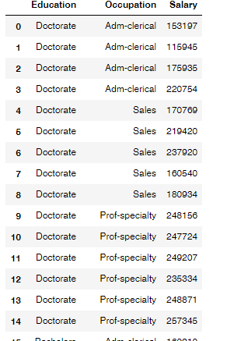
Table 1.1 Dataset of the Sample
From the above dataset it is evident that there are two categorical variables Education and Occupation and One Dependent variable is salary.

State the null and the alternate hypothesis for conducting one-way ANOVA for both Education and Occupation individually.

Null and Alternate Hypothesis for EDUCATION:

Null Hypothesis (H0) : Salary is dependent on the Education level.

Alternate Hypothesis (Ha): Salary is not dependent on the Education level.

Confidence level (P Value): 0.05

Null and Alternate Hypothesis for OCCUPATION:

Null Hypothesis (H0) : Salary is depended on the Occupation.
Alternate Hypothesis (Ha): Salary is not dependent on the Occupation.

Confidence level (P Value): 0.05

Perform a one-way ANOVA on Salary with respect to Education. State whether the null hypothesis is accepted or rejected based on the ANOVA results.

One Way Anova on Education:

- Degrees of freedom b/w the groups 2
- Degrees of freedom within the groups 117

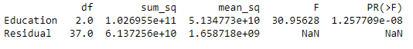
Table 1.2 One Way Anova Table - Education

From the above anova table, it is clearly evident that, p – value is less than 0.05 and as per the hypothesis stated for the Salary on Education, it is evident to reject the Null Hypothesis, which means that the salary is dependent on the Education Level.

Perform a one-way ANOVA on Salary with respect to Occupation. State whether the null hypothesis is accepted or rejected based on the ANOVA results.

One Way Anova on Occupation:

- Degrees of freedom b/w the groups 2
- Degrees of freedom within the groups 117

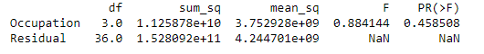
Table 1.3 One Way Anova Table - Occupation

From the above anova table, it is clearly evident that, p – value is not less than 0.05 and as per the hypothesis stated for the Salary on Occupation, it is evident that the test fails to reject the Null Hypothesis, which means that the salary is dependent on the Occupation.

Question 1B :

What is the interaction between two treatments? Analyze the effects of one variable on the other (Education and Occupation) with the help of an interaction plot.[hint: use the ‘pointplot’ function from the ‘seaborn’ function]

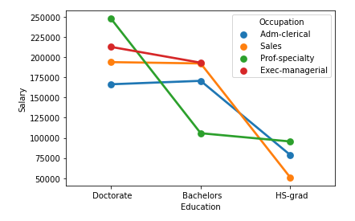
Fig No: 1.1 Pointplot with hue as Occupation

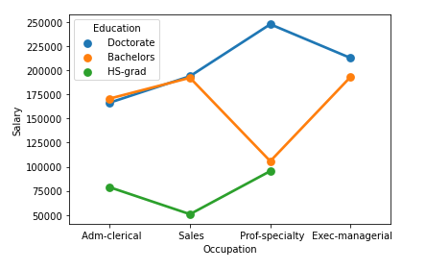
Fig.No 1.2 Point plot with hue as Education
From the above two figures it is evident that there is an interaction between the Education and Occupation. Education background with Doctorate earning high salary in all occupations than other educational backgrounds like Bachelors and HS grads in all occupations. Adm-clerical and sales professionals with bachelors and doctorate degrees earn almost similar salaries.

Perform a two-way ANOVA based on Salary with respect to both Education and Occupation (along with their interaction Education*Occupation). State the null and alternative hypotheses and state your results. How will you interpret this result?

Null and Alternate Hypothesis for interaction among EDUCATION and Occupation:

Null Hypothesis (H0) : Salary is dependent on both the Education level and Occupation.

Alternate Hypothesis (Ha): Salary is not dependent on the Education level and Occupation.

Confidence level (P Value): 0.05

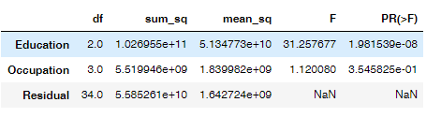

Table 1.4 Two Way Anova Table

From the above anova table, it is clearly evident that, p – value is less than 0.05 and as per the hypothesis stated for the Salary on Education and Occupation, it is evident that the test rejects the Null Hypothesis, which means that the salary is dependent on both Education level and Occupation.

Explain the business implications of performing ANOVA for this particular case study.

From the dataset given it is clearly evident that Education and Occupations have impact on the salary. Though three out of four occupations given in the data have doctorates, bachelors and HS grads, the salary is high among the Doctorates in all three occupations than the others.
From this, for any organization, hiring basis on the education levels can be considered to fix the range of the salary.

PROJECT 2: Principal Component Analysis

Problem Statement: Student Survey Data
The dataset contains information on various colleges. You are expected to do a Principal Component Analysis for this case study according to the instructions given

Sample of the dataset:
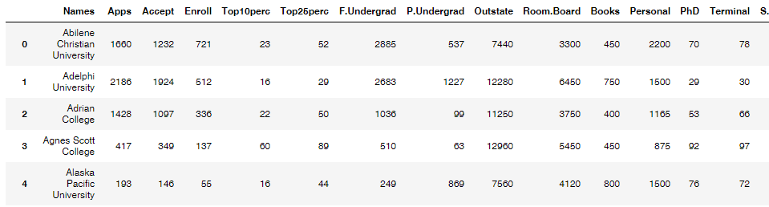
Table 2.1. Sample Dataset

Perform Exploratory Data Analysis [both univariate and multivariate analysis to be performed]. What insight do you draw from the EDA?

Exploratory Data Analysis:
- Data loading : Checked
- Info checked : Checked
- Null Values : Checked
- Duplicate values: Checked
- Statistical Description: Checked
Observations from the data:
Data consists of 777 colleges admission, enrollment and other details with 18 features
Full time undergraduate applications are more compared to the part time undergraduate applications.
The minimum alumni donations stands at 0.
There is a huge gap between the Minimum instructional Expenditure and Maximum instructional Expenditure per student.
There are no missing values in the data
We have 1 categorical fields as “Name” and one float field with Student Faculty Ratio
- After performing the univariate analysis the observations are as follows:
  - There are 17 numeric fields in the data
  - The minimum applications stands at 81 and maximum applications stands at 48094 for university given in the data set.
  - The minimum enrollment stands at 35 and maximum enrollment stands at 6392 for university given in the data set.
  - The minimum graduation rate rate stands at 10 and Maximum Graduation rate stands at 118.
  - The mean of student faculty ratio at among universities stand at 14.08.
  - There are more faculties with terminal degree than Phd degree with a mean difference of 7.
  - Outliers are present in all most all the numeric variables expect the Top 25% student data.
- After performing the bivariate analysis the observations are as follows:
  - There are considerable amount of features showing high or good correlation
  - The applications, acceptance and enrollment rates among the full time graduates are higher compared to part time graduates.
  - There is a high correlation between the application and acceptance rate.

Is scaling necessary for PCA in this case? Give justification and perform scaling.

Scaling is required in the given PCA data set as the given 17 numeric variables have different objectives to be determined so as had the maximum variances among components. For Example, No.of Applications and the Student Faculty ratio components in the data set have much stronger variance among them.
After performing the Z-Score Scaling the sample scaled data is as follows:
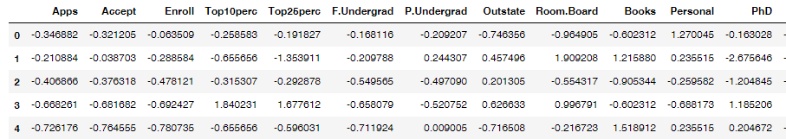
Table 2.2 Sample Scaled data
After performing the scaling we could able to reduce the variance among the components.
Scaling is performed on numeric components in the dataset.

Comment on the comparison between the covariance and the correlation matrices from this data [on scaled data].
Both the Correlation and Covariance matrix values ranges in between -1 to +1. When it comes to visualization the correlation matrix is more understandable than the covariance matrix. But in general for performing Eigen Values and Eigen Vectors we use Covariance matrix.
In this case, the values of covariance and correlation are almost same with very minute differences.
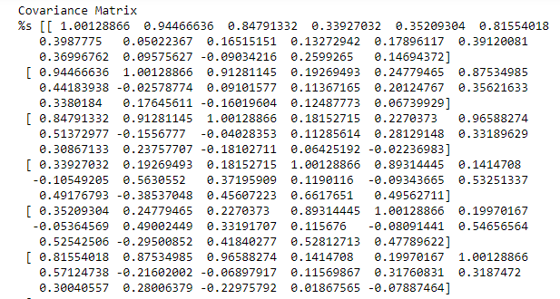
Table 2.3: Covariance Matrix
Correlation Matrix:
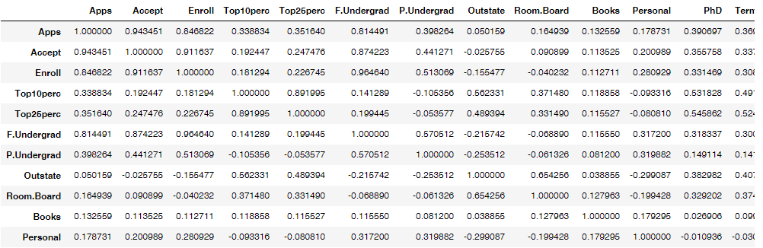
Table 2.4: Correlation Matrix
From the above matrices it is evident that there is no major difference between the values in both the Matrix

Check the dataset for outliers before and after scaling. What insight do you derive here? [Please do not treat Outliers unless specifically asked to do so]
Outlier before scaling:
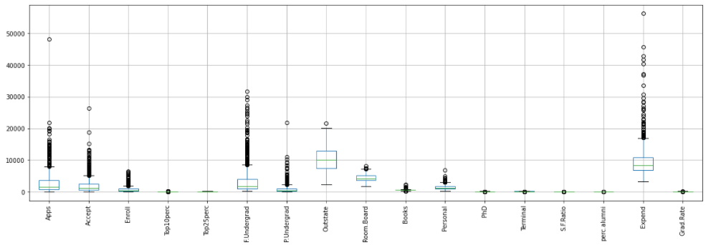
Fig 2.1 Outliers before Scaling
Outlier after scaling:
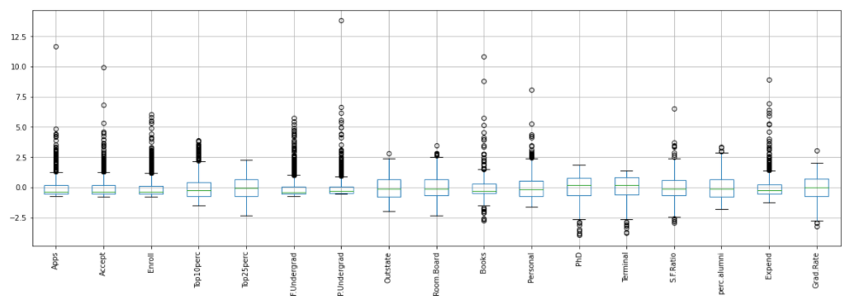
Fig 2.2 Outliers after Scaling

Observation:
- The median values before scaling is has a huge variance among the different variables whereas after scaling the median values among most of the variables are similar or same.
- The variance has been reduced.
- The outliers have been treated by some extent after scaling.

Extract the eigenvalues and eigenvectors.[Using Sklearn PCA Print Both]

Eigen Values from the data set are as below:
array([5.45052162, 4.48360686, 1.17466761, 1.00820573, 0.93423123,
0.84849117, 0.6057878 ])

Eigen Vectors from the data set are as below:
array([[ 0.2487656 , 0.2076015 , 0.17630359, 0.35427395, 0.34400128,
0.15464096, 0.0264425 , 0.29473642, 0.24903045, 0.06475752,
-0.04252854, 0.31831287, 0.31705602, -0.17695789, 0.20508237,
0.31890875, 0.25231565],
[ 0.33159823, 0.37211675, 0.40372425, -0.08241182, -0.04477866,
0.41767377, 0.31508783, -0.24964352, -0.13780888, 0.05634184,
0.21992922, 0.05831132, 0.04642945, 0.24666528, -0.24659527,
-0.13168986, -0.16924053],
[-0.0630921 , -0.10124906, -0.08298557, 0.03505553, -0.02414794,
-0.06139298, 0.13968172, 0.04659887, 0.14896739, 0.67741165,
0.49972112, -0.12702837, -0.06603755, -0.2898484 , -0.14698927,
0.22674398, -0.20806465],
[ 0.28131053, 0.26781735, 0.16182677, -0.05154725, -0.10976654,
0.10041234, -0.15855849, 0.13129136, 0.18499599, 0.08708922,
-0.23071057, -0.53472483, -0.51944302, -0.16118949, 0.01731422,
0.07927349, 0.26912907],
[ 0.00574141, 0.05578609, -0.05569364, -0.39543434, -0.42653359,
-0.04345437, 0.30238541, 0.222532 , 0.56091947, -0.12728883,
-0.22231102, 0.14016633, 0.20471973, -0.07938825, -0.21629741,
0.07595812, -0.10926791],
[-0.01623744, 0.00753468, -0.04255798, -0.0526928 , 0.03309159,
-0.04345423, -0.19119858, -0.03000039, 0.16275545, 0.64105495,
-0.331398 , 0.09125552, 0.15492765, 0.48704587, -0.04734001,
-0.29811862, 0.21616331],
[-0.04248635, -0.01294972, -0.02769289, -0.16133207, -0.11848556,
-0.02507636, 0.06104235, 0.10852897, 0.20974423, -0.14969203,
0.63379006, -0.00109641, -0.02847701, 0.21925936, 0.24332116,
-0.22658448, 0.55994394]])

Above are the Eigen Values and Eigen Vectors from the data set.

Perform PCA and export the data of the Principal Component (eigenvectors) into a data frame with the original features

The sample of the extracted data of the Principal Components into a data frame with the original features as follows:
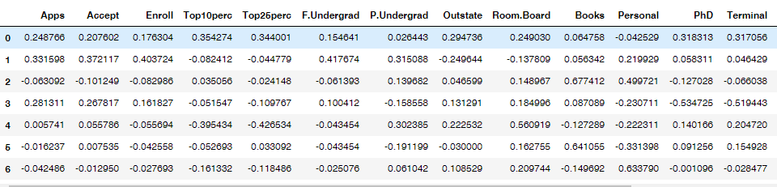
Table 2.5 Principal Component data

Write down the explicit form of the first PC (in terms of the eigenvectors. Use values with two places of decimals only). [hint: write the linear equation of PC in terms of eigenvectors and corresponding features]
PC0=a1x1+a2x2+a3x3+……+a7x7
eig_vals, eig_vecs = np.linalg.eig(cov_matrix)
PC0=0.25*Apps+0.21*accept+0.18*enroll+0.35*Top10perc+0.15*F.Undergrad+0.026*P.undergrad+0.29*outstate+0.25*Room.Board+0.065*Books+(0.043)*personal+0.32*Phd+0.32*Terminal+(0.18)*s.fratio+0.21*perc.alumni+0.32*Expend+0.25*Grad.rate
PC0=0.25+0.21+0.18+0.35+0.34+0.15+0.026+0.29+0.25+0.065+(0.043)+0.32+0.32+(0.18)+0.21 +0.32 +0.25
The principal ncipal component alone captured 32.02 % of the Data given.

Consider the cumulative values of the eigenvalues. How does it help you to decide on the optimum number of principal components? What do the eigenvectors indicate?
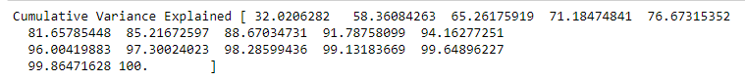
From the above cumulative variances of Eigen values we can say that, first 7 principal components have captured around 85% of the data.
By evident we can take 7 optimum number if principal components.
Eigen Vectors indicate that Eigen vectors with lowest Eigen values can be dropped without losing much information in the data.
From the above cumulative frequencies, it is clear that Principal Components from 8th value.

Explain the business implication of using the Principal Component Analysis for this case study. How may PCs help in the further analysis? [Hint: Write Interpretations of the Principal Components Obtained]
With help of PCA we have been able to reduce 17 numeric features into 7 components which is able to explain 85% of variance in the data.
With help of reduced components we have been able to observe some patterns. Using some rules around business context we are able to find out that more the enrollment more the Grad.Rate till certain point and gradually Grad.Rate decreases with the increase in the enrollment. Using the components additional rules can be derived and analyzed.
7 seven principal components help in the analyzing the data.
PCA also helps to keep check on the outliers as well.
Eigen Vectors are the principal components the corresponding Eigen values are the magnitudes or strength of the data.
Unsupervised learning like clustering can further be applied on the data to segment the customers based on the components created and further analyzed.
Sample analysis performed on PCA:
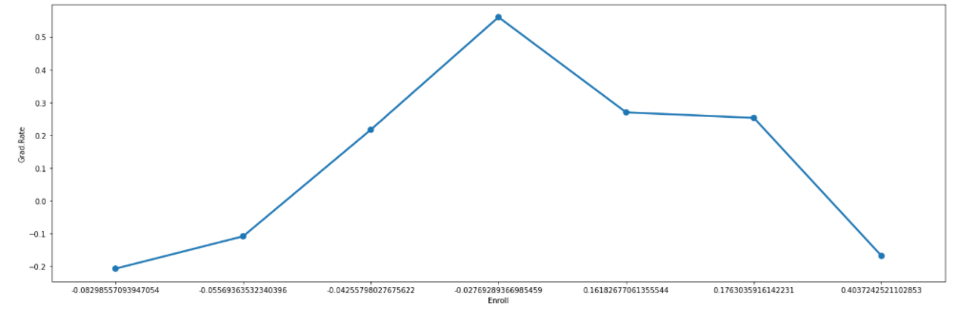
Fig 2.3 Sample analysis among the features after PCA
As per above sample example numerous analysis can be performed in business context.

